3GPP TSG-RAN WG1 Meeting #125 R1-2604307
Dalian, China, May 18 – 22, 2026

Agenda item: 10.8.2
Title: Views on Integration of Sensing with Communication in 6GR
Source: National Institute of Standards and Technology (NIST)
Document for: Discussion and Decision

Introduction
At the RAN1#124bis meeting, the scope of the RS study for ISAC was agreed upon: reuse of the communication RS, enhanced communication RS for sensing, and dedicated RS for sensing. Within this sub-agenda, the RE patterns of RS for sensing will be studied.
In addition, ISAC measurements, including definitions/levels for both TRP-side and UE-side measurements, as well as the measurement reporting mechanisms, will be studied.

According to the future lead’s summary [1], the plan for RAN1#125 is as follows:

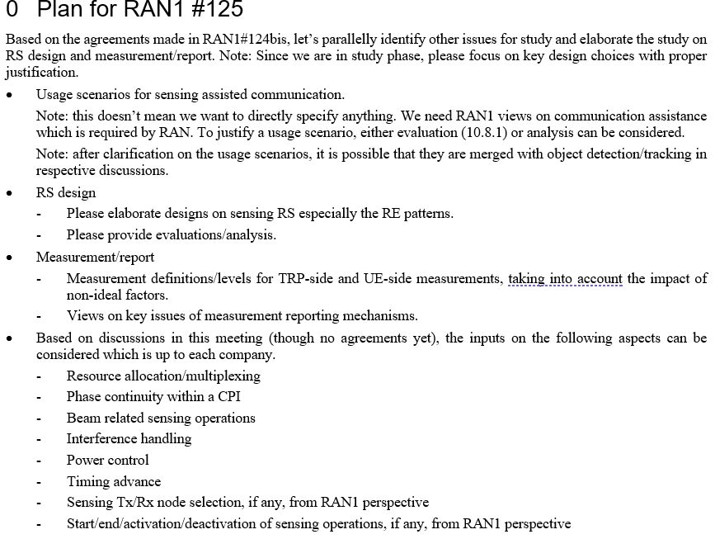

Sensing-assisted Communication
Target and environmental information obtained through sensing can assist communication. Typical usage scenarios include sensing-assisted predictive beamforming, sensing-assisted blockage mitigation, and CSI acquisition.

Sensing-Assisted Predictive Beamforming:
While conventional positioning techniques provide the UE's absolute or relative location, sensing extends this capability by not only enhancing positioning accuracy but also providing environmental awareness, such as the location of physical blockers or reflecting surfaces that are transparent to legacy positioning methods. The positioning service and the sensing-assisted communication enable proactive beam steering, effectively minimizing the latency and signaling overhead associated with conventional beam management (e.g., periodic beam sweeping, exhaustive searching, and retraining). Consequently, the network can maintain continuous high-throughput connectivity and significantly reduce service interruptions, particularly in high-mobility or dense urban scenarios.

Sensing-Assisted Blockage Mitigation: High-frequency bands (e.g., FR2) are highly susceptible to signal attenuation and blockage by physical obstacles such as buildings or vehicular traffic. By utilizing ISAC to maintain a dynamic, real-time map of the propagation environment, the network can detect potential blockage events before they occur. Upon predicting a Link Failure (LF) or significant signal degradation on the LOS path, the network proactively reconfigures the beam to utilize a pre-identified NLOS path with optimal reflection characteristics, thereby ensuring session continuity and robust RRM (Radio Resource Management).

CSI Acquisition
Additionally, in Multi-User MIMO (MU-MIMO) beamforming scenarios, CSI acquisition via RS may entail significant signaling complexity and is susceptible to estimation errors. By incorporating environmental awareness into the Radio Resource Management (RRM) framework, the network can utilize spatial and geometric data to enhance CSI estimates. This sensing-assisted method can lower feedback overhead and increase the accuracy of spatial multiplexing and inter-user interference cancellation.
To enable sensing-assisted communication, the sensing functionality involves two aspects, as shown in Figure 2.1:
- Environmental reconstruction: These can be created by integrating ISAC with other types of sensors, like LiDAR and cameras. The goal is to identify static features (e.g.,buildings) and understand signal reflections in the environment (e.g., which building has high reflectivity). These can be considered prior knowledge.
- Motion detection and prediction: By detecting objects’ velocity and trajectory, the obtained real-time information can be used to update the reconstructed environment and predict objects’ future positions.

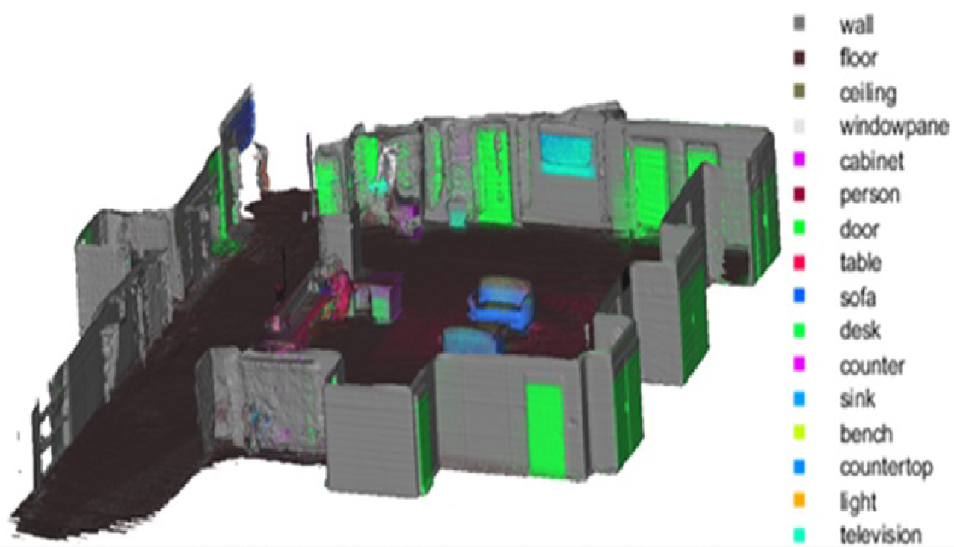 | 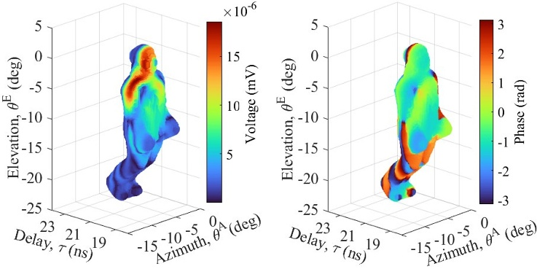

Figure 2.1 Example of multimodal sensing for sensing-assisted communication. Left: environment reconstruction and semantic segmentation obtained from collocated LiDAR and camera sensors. Right: human digital twin reconstructed from camera and LiDAR data and fused with RF measurements.

Observation 1: For high-fidelity environmental reconstruction and real-time digital twin updates, one primary function of ISAC is to generate and maintain an RF channel knowledge map. This map characterizes environmental reflections and can be overlaid on constructed environmental objects. Consequently, accurate estimation of delay, reflection angles (AoA/AoD), and their associated path powers are critical to support communication, such as proactive beam steering to avoid link failure.

Proposal 1: For sensing-assisted communication, the sensing measurements required for environment updates and motion detection should at least include the detected dominant MPCs and their associated parameters, such as delays, angles, and power levels.

Sensing Reference Signal (RS)
The sensing performance is fundamentally governed by the signal’s bandwidth, its resource mapping within the OFDM grid (e.g., comb size), the sensing interval, and the total observation duration, as characterized by the following metrics:

Table 1: Mapping of Sensing KPIs to the RS Parameters
Sensing KPIs | Formula | Dependency
Max Unambiguous Range | $$d_{max}=\frac{c_{0}}{2{∙K}_{comb}∙Δf}$$ | Comb size ($K_{comb})$ and subcarrier spacing ($Δf)$
Range Resolution | $$ΔR=\frac{c_{0}}{2∙BW}$$ | Total occupied bandwidth ($BW$)
Max Unambiguous Velocity | $$v_{max}=\frac{c_{0}}{4∙f_{c}∙T_{s}}$$ | Sensing interval ($T_{s}$) and carrier frequency ($f_{c}$)
Velocity Resolution | $$Δv=\frac{c_{0}}{2{∙f}_{c}∙{MT}_{s}}$$ | Total observation duration ($MT_{s}$) and carrier frequency ($f_{c}$)

Additionally, how effectively the reference signal can manage intra- and inter-cell interference is important. The availability of the reference signal, in connected mode and/or in the idle mode, must also be considered when assessing its suitability.

Since the 6G RS design for communication is an ongoing effort, we can start the study based on 5G reference signals. Among the 5G NR reference signals, PRS, CSI-RS/TRS, DMRS, and SSB can be considered for downlink sensing, while DMRS and SRS can be used for uplink sensing. The characteristics of these NR reference signals are listed in the table below.

Table 2: 5G NR Reference Signals
 | BW | Comb Size | Number of Symbols per slot | Typical Period | Other Aspects
PRS | 24 – 272 PRBs (an increment of 4) | 2, 4, 6, 12 | - 1, 2, 4, 6, 12 symbols per slot  - Can occupy multiple consecutive time slots. | 4, 5, 8, 10, 16, 20 …10240 slots | Available in both RRC connected and RRC idle/inactive states  Muting features for inter-cell coordination  Downlink only
CSI-RS | Span the entire BWP | One RE every PRB or two PRBs | 1, 2, or 4 symbols. Two symbols must be adjacent | Occurs every N slots, where N is between 4 and 640. | Used in the RRC connected state  ZP CSI-RS to handle inter-cell interference  Downlink only
TRS | Span the entire BWP | 4 | 2 symbols with a four-symbol separation | 20, 40, 80, 160 ms, two consecutive slots | Connected and idle state  Serving cell only  Downlink only
DMRS | Confined by data allocation | 2, or 2 consecutive subcarriers every 6 subcarriers | Maximum 4 symbols with some constraints  Support mapping type A and mapping type B | N/A | Used when data is being transmitted.  Limited to the serving cell and the link  Both uplink and downlink
PSS/SSS | 127 subcarriers | consecutive | The 1st symbol/3rd symbol in an SSB | Configurable 5ms – 160ms | Primary for the idle state  Downlink only
SRS | Configurable, between 1 and 127 PRBs | 2 or 4 combs | 1, 2, or 4 OFDM symbols | With a typical period of 20, 40, 80, 160 ms  Also support Semi-persistent and aperiodic configuration | Connected mode  Uplink only

The main purpose of the existing reference signals is channel estimation, beamforming, and link adaptation, rather than sensing. Therefore, they are not optimized for sensing applications. For example, the limited bandwidth of the SSB restricts the achievable range resolution. Similarly, CSI-RS and TRS may not meet sensing needs because of their sparse resource allocation in the time and frequency domains. In addition, RS availability and interface management capability also influence sensing performance. For instance, DRMS is only available during active data transmission, which may not always occur or may not be beamformed toward the target. Furthermore, to enhance sensing performance, CSI-RS/TRS may require multiple configurations to increase the RS density in the frequency and/or time domains.

In RAN1#124bis, it has been agreed that the RS study for ISAC should include three aspects, i.e., communication RS reused for sensing, enhanced RS for sensing, and dedicated RS for sensing. Among them, reusing communication RS, including RE pattern design, will be handled in this agenda, and other new enhancements for RS, including RS sequence design, will be handled in 10.8.3.

To study the RS for sensing, as the first step, we should evaluate the sensing capabilities of the existing RSs for communication, such as CSI-RS/TRS and SRS, to understand their capabilities and limitations and use them as a baseline for the study.

Proposal 2: As a starting point, evaluate the sensing capabilities of the existing communication RSs, such as CSI-RS/TRS and SRS, across different sensing modes and deployment scenarios. When a clear performance gap is identified, study how it can be addressed through RE pattern design.

When evaluating the sensing capability of a reference signal, a number of factors need to be considered, such as maximum unambiguous range, range resolution, maximum unambiguous velocity, velocity resolution, sensing overhead, complexity of the sensing algorithms, the effectiveness of the reference signal in managing intra- and inter-cell interference, as well as its availability in connected or idle modes, and if data transmission is required.

Proposal 3: At least the following factors should be considered when evaluating the sensing performance of an RS
- Maximum unambiguous range
- Maximum unambiguous velocity
- Range resolution
- Velocity resolution
- Angular estimation capability and spatial coverage
- Complexity of the sensing algorithm for the RS
- Sensing overhead
- Interference management capability, including intra- and inter-cell interference management

Measurement and Reporting Framework
At the RAN1#124-bis meeting, some agreements regarding ISAC measurements have been made as follows:
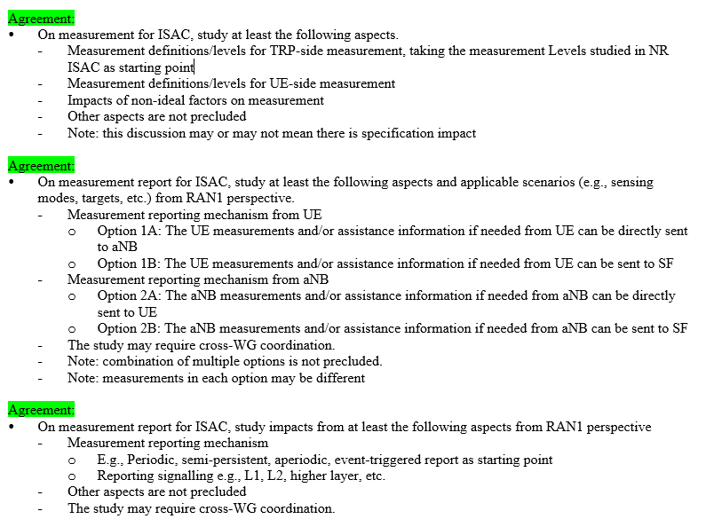

It was agreed to study measurement definitions and levels for both TRP-side and UE-side sensing, and to use the four-level measurements characterized in the 5G-A ISAC study as a starting point for defining TRP-side measurement. These levels define the measurement granularity from the gNB to the Sensing Function (SF):

- Level A: Raw data (e.g., Channel Impulse Response or frequency domain samples).
- Level B: Processed profiles in the delay, Doppler, and angular domains.
- Level C: Extracted path or point measurements (e.g., range, velocity, and 3D angles).
- Level D: Finalized object-level state vectors (e.g., object’s position and velocity).

Fundamentally, these measurement levels delineate the functional split between the sensing receiver and the SF. While Level A enables high-fidelity sensing fusion within SF, it requires transferring massive data volumes. Conversely, Level D shifts processing burden to the sensing node, significantly reducing data transmission overhead.

When a UE participates as a sensing receiver, this tradeoff becomes even more critical because of the limited bandwidth of the Uu interface and UE power/processing constraints. Transmitting low-level measurements (such as Level A or Level B) via the air interface may become impractical, as it introduces substantial signaling overhead and consumes excessive uplink resources. Furthermore, raw profiles often contain sparse relevant information, leading to inefficient resource utilization. While higher-level results (such as Levels C or D) alleviate these overhead concerns, generating accurate Level D results independently may challenge the UE’s limited computational capability and spatial view. To balance these competing requirements, a flexible UE reporting framework can be established to accommodate various UE types and deployment scenarios.

Proposal 4: A flexible UE reporting framework should be established to account for trade-offs between UE processing capability and communication overhead.
Proposal 5: For 6G ISAC, the measurement reporting framework should support a multi-level measurement report mechanism with a focus on payload size characterization and overhead reduction. Specifically, RAN1 should study:
- The feasibility and impact of Level A/B measurement reporting over the Uu interface.
- The trade-off between measurement reporting level and UE processing capabilities.
Reporting raw or high-resolution sensing data across the delay, angle, and Doppler domains poses a significant technical challenge for 6G ISAC. Therefore, it is essential to evaluate the payload size across all reporting levels, from Level A to Level D, to ensure that the reporting framework is compatible with UE processing capabilities and does not adversely impact standard communication services.
In the bistatic sensing configurations, to generate high-level "Level D" sensing results, such as target position and velocity within a GCS, the SRX requires specific assistance information to resolve sensing geometry. For example, in TRP-UE bistatic sensing, the UE may need STX’s location information and detailed beamforming parameters, including boresight orientation and beam index mapping, to estimate the target location. Conversely, if the sensing results are processed at the TRP, the UE’s location and velocity may be required as assistance data. Furthermore, when sensing results are calculated centrally within a Sensing Function (SF), the framework must account for the various assistance data requirements across all sensing modes to ensure accurate object detection and tracking.
Proposal 6: RAN1 to identify the necessary bidirectional assistance information and associated signaling procedures between the STX and SRX for bistatic sensing modes. This includes, but is not limited to, STX location and, possibly, beam information to enable target detection at either the SRX or the STX.
Proposal 7: RAN1 to study and identify the sensing assistance information and measurement reporting levels required when sensing processing is performed in the SF.
For sensing-assisted communication, achieving good spatial awareness of the propagation environment often requires multi-node coordination and active UE participation. Meanwhile, the aNB requires low-latency access to sensing results to execute time-critical functions such as proactive beam management or blockage prediction. The reporting requirements for sensing-assisted communication must be highly adaptive, as the necessary measurement granularity depends on the specific assistance objective. For instance, while basic object tracking may rely on high-level results (like Level D), detailed environment reconstruction (e.g., mapping static walls or buildings) may require more granular path-level data (like Level C) to build a comprehensive "Digital Twin" of the environment.
Furthermore, the architectural choice for the reporting path is critical. A transparent reporting mechanism to an SF may prioritize UE privacy, but non-transparent reporting directly to the aNB is often necessary to minimize the processing latency required for standard communication enhancements.

Proposal 8: Study the measurements for sensing-assisted communication from the following aspects:
- Characterize Requirements by Use Case: Evaluate the required measurement levels for specific features, such as environment reconstruction, CSI acquisition assistance, and proactive beam alignment.
- Evaluate Transport Mechanisms: Analyze the signaling overhead and latency of transmitting sensing results via L1, L2, and higher-layer protocols to meet stringent 6G communication requirements.

ISAC Considerations
In this section, we will cover some important considerations for ISAC.

5.1 Dynamic Sensing Node Selection
The sensing procedures need to accommodate diverse deployment scenarios, including monostatic, bistatic, and multistatic sensing configurations. To achieve effective coverage of a given sensing area or target, selecting the optimal set of sensing nodes is non-trivial and critical for balancing sensing accuracy and signaling overhead.
Furthermore, for tracking a mobile target, a static node setup may not be ideal. As the target moves, sensing resources should be proactively activated in the anticipated activity area, while those in the previously covered sensing area should be deactivated to conserve energy and minimize interference. Therefore, the 6G sensing framework should support dynamic node selection and reconfiguration to efficiently adapt to target mobility.
Proposal 9: The 6G sensing framework should support dynamic node selection and reconfiguration to efficiently adapt to the target's movement, minimize interference, and conserve energy. RAN1 should study schemes for selecting sensing nodes and determine the required measurements.

5.2 Interference Mitigation
Many interference issues can occur in an ISAC network, including interference between sensing and communication functions, among different sensing nodes, and self-interference within individual TRPs or UEs.
For example, multiple TRP sensing, whose benefits have been demonstrated in the 5G-Advanced ISAC studies [2], may require higher transmit power for sensing signals to detect targets beyond the nominal coverage area. As a result, the high-power DL sensing reference signals transmitted by aNB can interfere with the DL communication signals received by UEs in neighboring cells. Additionally, adjusting TRP antenna downtilt to detect aerial objects can introduce significant cross-link interference toward neighboring aNBs. To manage such inference, coordinate resource allocation and spatial domain interference mitigation techniques can be applied at the network level. Also, power control can be leveraged to increase the desired signal power or reduce the interference power.
Proposal 10: RAN1 shall investigate the interference characteristics and corresponding mitigation techniques and measurement requirements for ISAC.

5.3 Sensing Nodes Synchronization
To support distributed sensing topologies, including bistatic and multistatic configurations, the 6G system needs synchronization among sensing nodes and, in some cases, high-precision synchronization of timestamps and carrier phases across sensing entities to combine high-fidelity sensing measurements. Errors in temporal or spectral alignment may directly reduce the accuracy of range and Doppler estimations.
Proposal 11: To facilitate multi-node sensing, it is important to study the requirements and solutions for synchronization across multiple nodes.

Conclusions
In this document, we propose several usage scenarios for sensing-assisted communication and their associated measurement requirements. We examined the NR reference signals and outlined the fundamental requirements for sensing RS. We also discussed the measurement and reporting framework for UE-based measurement reporting and sensing-assisted communication. Finally, we discussed several key aspects to consider when integrating sensing with communication in 6G. Our proposals are as follows:

Observation 1: For high-fidelity environmental reconstruction and real-time digital twin updates, one primary function of ISAC is to generate and maintain an RF channel knowledge map. This map characterizes environmental reflections and can be overlaid on constructed environmental objects. Consequently, accurate estimation of delay, reflection angles (AoA/AoD), and their associated path power level is critical to support communication, such as proactive beam steering to avoid link failure.

Proposal 1: For sensing-assisted communication, the sensing measurements required for environment updates and motion detection should at least include the detected dominant MPCs and their associated parameters, such as delays, angles, and power levels.

Proposal 2: As a starting point, evaluate the sensing capabilities of the existing communication RSs, such as CSI-RS/TRS and SRS, across different sensing modes and deployment scenarios. When a clear performance gap is identified, study how it can be addressed through RE pattern design.

Proposal 3: At least the following factors should be considered when evaluating the sensing performance of an RS
- Maximum unambiguous range
- Maximum unambiguous velocity
- Range resolution
- Velocity resolution
- Angular estimation capability and spatial coverage
- Complexity of the sensing algorithm for the RS
- Sensing overhead
- Interference management capability, including intra- and inter-cell interference management

Proposal 4: A flexible UE reporting framework should be established to account for trade-offs between UE processing capability and communication overhead.

Proposal 5: For 6G ISAC, the measurement reporting framework should support a multi-level measurement report mechanism with a focus on payload size characterization and overhead reduction. Specifically, RAN1 should study:
- The feasibility and impact of Level A/B measurement reporting over the Uu interface.
- The trade-off between measurement reporting level and UE processing capabilities.
Proposal 6: RAN1 to identify the necessary bidirectional assistance information and associated signaling procedures between the STX and SRX for bistatic sensing modes. This includes, but is not limited to, STX location and, possibly, beam information to enable target detection at either the SRX or the STX.
Proposal 7: RAN1 to study and identify the sensing assistance information and measurement reporting levels required when sensing processing is performed in the SF.
Proposal 8: Study the measurements for sensing-assisted communication from the following aspects:
- Characterize Requirements by Use Case: Evaluate the required measurement levels for specific features, such as environment reconstruction, CSI acquisition assistance, and proactive beam alignment.
- Evaluate Transport Mechanisms: Analyze the signaling overhead and latency of transmitting sensing results via L1, L2, and higher-layer protocols to meet stringent 6G communication requirements.
Proposal 9: The 6G sensing framework should support dynamic node selection and reconfiguration to efficiently adapt to the target's movement, minimize interference, and conserve energy. RAN1 should study schemes for selecting sensing nodes and determine the required measurements.
Proposal 10: RAN1 shall investigate the interference characteristics and corresponding mitigation techniques and measurement requirements for ISAC.
Proposal 11: To facilitate multi-node sensing, it is important to study the requirements and solutions for synchronization across multiple nodes.

References

[1] | Moderator (Xiaomi), R1-2602592, "Summary #4 on integration with communication for ISAC," April 2026 (RAN1#124bis).
[2] | TR38.765, "Study on Integrated Sensing And Communication (ISAC) for NR (Release 20)," 2026-02.
[3] | RP-260282, "Revised SID: Study on 6G Radio," Fukuoka, Japan, March 2026 (RAN #111).

